



Essay / Assignment Title: Deep Learning Driven Image Segmentation for Enhanced Diagnostic Accuracy in Medical Imaging
Programme title: Computer Vision and Artificial Intelligence
Name: Naga Surendera Babu Aravapalli
Year: 2026

CONTENTS

Table of Contents
CONTENTS 2
Table of Contents 2
List of Figures: - 5
List of Tables: - 5
INTRODUCTION 7
0.1 Abstract 7
0.2 Introduction 7
0.3 Literature Review 7
0.4 Problem Formulation 8
0.5 Dataset Preparation 9
1. CHAPTER ONE (Model Architecture) 10
1.1 U-Net Architecture: - 10
1.2 Pre-processing status: - 11
1.3 Segmentation process: - (Sample Images collected to show) 11
2. CHAPTER TWO (Implementation) 15
2.1 The implementation pipeline includes: Data loading and preprocessing. 15
2.2 Train the Model: - 15
2.3 Evaluation model: - 15
2.4 Classification Metrics report: - (Confusion Metrics) [8] 16
2.5 Metrics Explained: - 17
2.6 Plot accuracy/loss curves analysis: - [9] 18
2.7 Dice Score vs Epochs: - 20
2.8 Dice Loss vs Epochs: - (Training and validation loss curves across epochs) 21
3. CHAPTER THREE (Model Evaluation) 22
3.1 Model predict – Visualize segmentations: - 22
3.2 Training Loss pattern: - 23
3.3 Model Comparison (Dice Score): - 24
3.4 Performance of Train and Test Data: - 25
3.5 Prediction distribution: - 26
4. CONCLUDING REMARKS 27
4.1 Findings: - 27
4.2 Recommendations: - 27
BIBLIOGRAPHY 29
1. Hu, M., Lin, H., Fan, Z., Gao, W., Yang, L., Liu, C. and Song, Q., 2020. Learning to recognize chest-Xray images faster and more efficiently based on multi-kernel depthwise convolution. IEEE Access, 8, pp.37265-37274. 29
2. Alqahtani, F.F., Mohsan, M.M., Alshamrani, K., Zeb, J., Alhamami, S. and Alqarni, D., 2024. Cnx-b2: a novel cnn-transformer approach for chest x-ray medical report generation. Ieee Access, 12, pp.26626-26635. 29
3. Ahmed, K.B., Goldgof, G.M., Paul, R., Goldgof, D.B. and Hall, L.O., 2021. Discovery of a generalization gap of convolutional neural networks on COVID-19 X-rays classification. Ieee Access, 9, pp.72970-72979. 29
4. Iqbal, S., Qureshi, A.N., Khan, F., Aurangzeb, K. and Akbar, M.A., 2024. From Data to Diagnosis: Enhancing Radiology Reporting with Clinical Features Encoding and Cross-Modal Coherence. IEEE Access. 29
5. Fu, M., Tantithamthavorn, C. and Le, T., 2025. DAViT: A domain-adapted vision transformer for automated pneumonia detection and explanation using chest X-ray images. IEEE Access. 29
6. Khan, W., Zaki, N. and Ali, L., 2021. Intelligent pneumonia identification from chest x-rays: A systematic literature review. IEEE Access, 9, pp.51747-51771. 29
7. Gazda, M., Plavka, J., Gazda, J. and Drotar, P., 2021. Self-supervised deep convolutional neural network for chest X-ray classification. IEEE Access, 9, pp.151972-151982. 29
8. Ahsan, M.M., Ahad, M.T., Soma, F.A., Paul, S., Chowdhury, A., Luna, S.A., Yazdan, M.M.S., Rahman, A., Siddique, Z. and Huebner, P., 2021. Detecting SARS-CoV-2 from chest X-Ray using artificial intelligence. Ieee Access, 9, pp.35501-35513. 29
9. Nahiduzzaman, M., Goni, M.O.F., Anower, M.S., Islam, M.R., Ahsan, M., Haider, J., Gurusamy, S., Hassan, R. and Islam, M.R., 2021. A novel method for multivariant pneumonia classification based on hybrid CNN-PCA based feature extraction using extreme learning machine with CXR images. IEEE Access, 9, pp.147512-147526. 29
10. Cao, K., Zhang, K., Li, L. and Jung, H., 2025. EfficientMFRF-BiFPN: A CNN-Transformer Hybrid with Multi-Feature Representation Fusion for Pneumonia Detection. IEEE Access, 13, pp.193786-193801. 30
APPENDIX (if necessary) 31

List of Figures: -
Figure 1 U-Net Diagram 10
Figure 2: Preprocessing status 11
Figure 3 Image segmentation process 13
Figure 4: Confusion Metrics 17
Figure 5: accuracy/loss curves 18
Figure 6 Dice Score V/s Epochs 20
Figure 7 Dice Loss V/s Epochs 21
Figure 8 Model predict – Visualise segmentations 22
Figure 9 Training Loss pattern 23
Figure 10 Model Comparison 24
Figure 11 Train and Test Data Performance 25
Figure 12: Prediction distribution 26

List of Tables: -
Table 1 Segmentation Process 12
Table 2 Validation Accuracy 16
Table 3 Plot Accuracy V/s Loss Curves 18
Table 4 Model Layers 19

Statement of compliance with academic ethics and the avoidance of plagiarism

I honestly declare that this dissertation is entirely my own work and none of its part has been copied from printed or electronic sources, translated from foreign sources and reproduced from essays of other researchers or students. Wherever I have been based on ideas or other people texts I clearly declare it through the good use of references following academic ethics.
(In the case that is proved that part of the essay does not constitute an original work, but a copy of an already published essay or from another source, the student will be expelled permanently from the program)

Name and Surname (Capital letters): NAGA SURENDERA BABU ARAVAPALLI
Date: 31/01/2026

INTRODUCTION

0.1 Abstract
Image segmentation is an essential process in medical image analysis, allowing accurate separation of regions of interest within an image. This assignment concentrates on the improvements and compilation of a U-Net-based deep learning model for binary segmentation tasks. Dice loss and the Dice coefficient were adopted to handle class imbalance and to evaluate segmentation performance. The model was trained using prepared image–masking datasets, and its performance was analyzed through training and validation results. The findings indicate that the implemented U-Net model can effectively learn segmentation patterns and serves as a reliable approach for medical image segmentation applications.

0.2 Introduction
Image segmentation is a critical component of medical imaging, as it supports the accurate identification and analysis of anatomical regions and abnormalities. Conventional image processing techniques often face limitations while connecting with difficult medical images, leading to the increased adoption of deep learning methods. The U-Net architecture has gained popularity in this domain due to its ability to combine contextual feature extraction with precise localization through skip connections. In this assignment, a U-Net model was developed and compiled to perform binary image segmentation. Emphasis was placed on network design, dataset preparation, and the selection of appropriate loss functions and evaluation metrics. The objective of this work is to demonstrate the effectiveness of the U-Net architecture and highlight its potential for medical image segmentation tasks.

0.3 Literature Review
Medical image segmentation has received significant attention because of its important role in supporting accurate diagnosis and clinical decision-making. Early segmentation methods were mainly based on traditional image processing techniques [7], such as thresholding, edge detection, and region-growing. While these approaches were suitable for simple images, they often struggled with complex medical images due to noise, low contrast, and structural variability, which limited their effectiveness.
With advances in deep learning, convolutional neural networks (CNNs) turned into prior approach to medical image segmentation process. CNNs learn important features automatically out of raw data, removing the need for manual feature extraction. Among different CNN-based models [5], U-Net is widely used in medical imaging. Its encoder–decoder structure with skip connections helps capture contextual information while preserving spatial details, which improves segmentation accuracy.
Numerous studies have reported successful applications of U-Net in medical image analysis, including organ segmentation, tumour detection, and skin lesion segmentation. One of the key advantages of U-Net is its ability to achieve strong performance even with limited training data, which is common in medical datasets. Additionally, Dice-based loss functions are frequently used in segmentation tasks to effectively handle class imbalance between foreground and background regions.
Recent research efforts have proposed several enhanced versions of U-Net, such as Attention U-Net, U-Net++, and residual-based models, to further improve segmentation performance. These variants focus on better feature representation and improved localisation. Despite these developments, the original U-Net architecture remains widely used due to its simplicity, efficiency, and reliable results. This assignment follows established research by implementing a U-Net model to demonstrate its effectiveness in medical image segmentation.

0.4 Problem Formulation
Image segmentation in medical imaging aims to accurately distinguish regions of interest from surrounding background pixels, which is challenging due to noise, variability in image appearance, and complex structures. In this work, the problem is defined as a binary pixel-level classification task, where each pixel in a medical image is assigned either to the target region or to the background. The goal is to produce a segmentation mask that precisely represents the region of interest for a given input image.
A supervised learning approach is adopted using paired images and corresponding ground truth masks to train a U-Net model. The network learns to predict segmentation masks by optimizing a loss function that measures the difference between predicted outputs and reference masks. Dice loss is utilized for demonstrate class imbalance and improve segmentation accuracy. Model performance is assessed using the Dice coefficient, which evaluates the degree of overlap between predicted and actual masks. The objective is to develop an effective and reliable model capable of accurately segmenting medical images.

0.5 Dataset Preparation
The dataset preparation process involved selecting a medical image dataset with input images and corresponding ground truth masks and dataset chosen from Kaggle website. Image pixel values were normalized to the range of [0,1] by dividing with 255. The fixed resolution for images and masks were 224 x 224 pixels. The dataset has divided into different categories like training, validation, and test sets for evaluation. Data augmentation methods such as rotation, flipping, and scaling were applied to the training data to reduce overfitting, ensuring that images and masks were augmented together. Masks types were converted into binary or multi-class labels. The fixed ratio to split the dataset randomly is 70% - Training, 15% - Validation, 15% - Testing. Image type is RGB or grayscale.
Batch Sizes: -
Image Classification: 16, 32, 64
Image Segmentation (U-Net): 4, 8, 16 (due to large memory usage)

1. CHAPTER ONE (Model Architecture)

1.1 U-Net Architecture: -
Given its apparent viability in restorative picture division and its comparatively low computing complexity, the U-Net architecture was chosen for this consideration.

U-Net: - U-Net is a part of a neural network used for image segmentation. It’s dividing an image into various parts to indicate specific objects. For an instance separating a tumor from healthy tissue in a medical scan. The “U-Net” name comes from its architecture, the letter “U” that is used in medical imaging to handle even a small amount of labelled data. It interacts with multiple encoder and decoder blocks and in between includes a bottleneck in the middle. Finally, the output layer utilizes a sigmoid activation for segmentation.
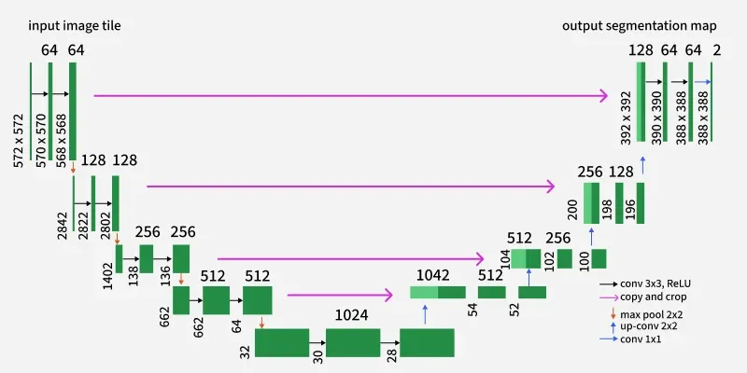
Figure 1 U-Net Diagram

1.2 Pre-processing status: -
It shows preprocessing status of the chest X-ray dataset images processed successfully. It classified the dataset three sets train, test and validation. Each set of images further divided into two classes Normal (Healthy lungs) and Pneumonia (Infected lungs).
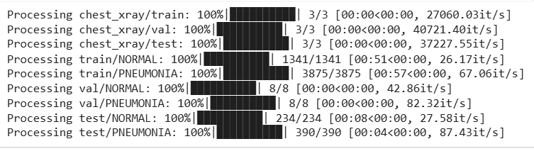
Figure 2: Preprocessing status
Observations: -
The number of images processed is imbalanced between the training and test sets, while the validation set is balanced. This may increase the model’s bias toward pneumonia predictions.
Training set: NORMAL: 1341 images, PNEUMONIA: 3875 images
Validation set: NORMAL: 8 images, PNEUMONIA: 8 images
Test set: NORMAL: 234 images, PNEUMONIA: 390 images
- High processing speed indicates the efficiency of data loading and preprocessing.
- Proper dataset seggregation (train/validation/test) will control the data lekage.
- The dataset structure suitable to binary image classifications like pneumonia detection.

1.3 Segmentation process: - (Sample Images collected to show)
The segmentation process effectively isolates lung regions from chest X-ray images, enabling focused analysis for pneumonia detection.
The Image segmentation process has differenciated and explained for both original V/s Segmentation images in a tablular format below.
Sl.No. | Original Images | Segmentation Images
1 | It is on Left side. | These images are on Right side.
2 | Chest X-ray images from both Normal and Pneumonia classes. | The segmentation process generates the binary segmentation masks.
3 | The lung structure has displayed with colour. | White regions represent to detect lung areas where as Black regions represents the background and non-lung areas.
4 | It views anatomical regions such as lungs, ribs and spine. | The segmentation process focuses on isolation the lungs from rest of the chest.
Table 1 Segmentation Process
The image segmentation is performed on the Original images for both training and testing purposes.

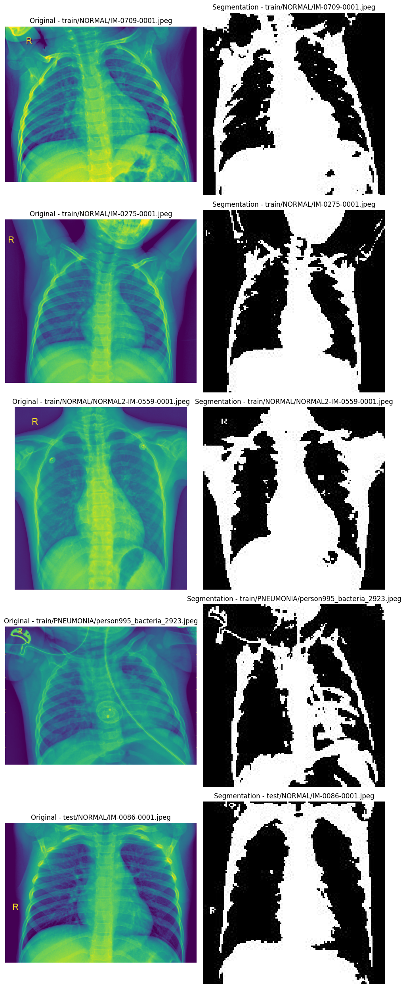
Figure 3 Image segmentation process
Observations: -
- The segmentation from most of the images separates lung regions from the background.
- Lung shapes are clearly visible and effectively indicating the boundaries.
- Some segmentation masks near the lung borders shows irregular or noisy edges.
- In case of Pneumonia the lung regions appear less uniform and viewing infection-affected areas.
- The approach is suitable for medical image preprocessing before classification and Preprocessing or thresholding will minimize the loss of final details.
- The output simplifies complex X-ray images into clear binary masks to proceed further analysis.

2. CHAPTER TWO (Implementation)

The model is implemented using Python and the PyTorch deep learning framework.

2.1 The implementation pipeline includes: Data loading and preprocessing.
- Using custom PyTorch datasets U-Net model definition Loss function selection (Dice Loss combined with Binary Cross-Entropy) optimization.
- The Adam optimizer is employed for both training and validation loops.

2.2 Train the Model: -
- The training progress of a deep learning model was considered over 20 epochs.
- Training accuracy steadily increases from about 95% to over 99% where as the Training loss consistently decreases.
- Epochs progress for Validation accuracy remains around 86 – 88%, whereas the Validation loss increases significantly.

Observations: -
The training model shows the good learning on the training data with high accuracy and decreasing training loss, indicating successful optimization.
The validation accuracy remains almost constant while the validation loss continues to increase, indicating no improvement in performance on unseen data.
The growing gap between training and validation performance suggests overfitting, but the model memorizes the training data and additional epochs do not enhance generalization.

2.3 Evaluation model: -
- The model gained a good validation accuracy (86.92%) but relatively low test accuracy (68.45%), indicating poor generalization to unseen data.
- The increase in test loss suggests overfitting but model performs well on known data but struggles with new samples.

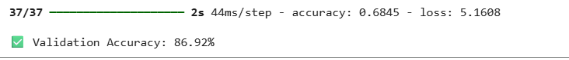
Table 2 Validation Accuracy

2.4 Classification Metrics report: - (Confusion Metrics) [8]
Convolutional neural network for chest X-ray classification and Confusion metrics formulae to classify the report as per metrics.
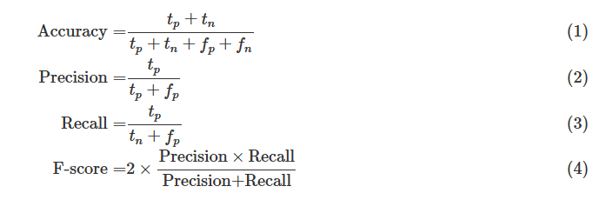
where,
The classification task (treating PNEUMONIA as "patient" and NORMAL as "healthy") provided metrics as follows:
TP (True Positive): A PNEUMONIA image classified as PNEUMONIA.
FP (False Positive): A NORMAL image classified as PNEUMONIA.
TN (True Negative): A NORMAL image classified as NORMAL.
FN (False Negative): A PNEUMONIA image classified as NORMAL.
This classification report indicates the performance of model on the standard dataset using standard evolution metrics.
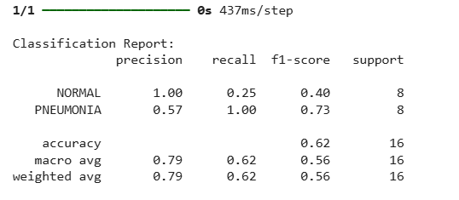
Figure 4: Confusion Metrics

2.5 Metrics Explained: -
- Precision: How many predicted positives are actually correct.
- Recall: How many actual positives are correctly identified?
- F1-Score: Harmonic mean of precision and recall.
- Support: Number of trails in every class.

Observations: -

- The model effectively detects pneumonia (high recall of 1.00), but it is poor at identifying normal cases (low recall of 0.25), which leads to biased predictions.
- Overall performance accuracy 62%, which is moderate due to imbalanced class predictions. This behaviour is risky in medical diagnosis as it may cause false alarms.

2.6 Plot accuracy/loss curves analysis: - [9]
Metric | Training | Validation
Dice Score (Accuracy) | ↑ Increasing | ↓ Slightly decreasing
Loss | ↓ Decreasing | ↑ Increasing
Table 3 Plot Accuracy V/s Loss Curves
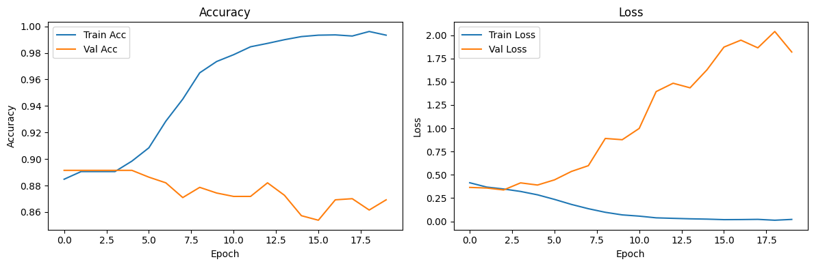
Figure 5: accuracy/loss Curves
Observations: -
- The best generalization performance likely occurs around epoch 3-5.
- Continuing training beyond that harm’s validation performance.

The training and validation loss curves were generated during experimentation.

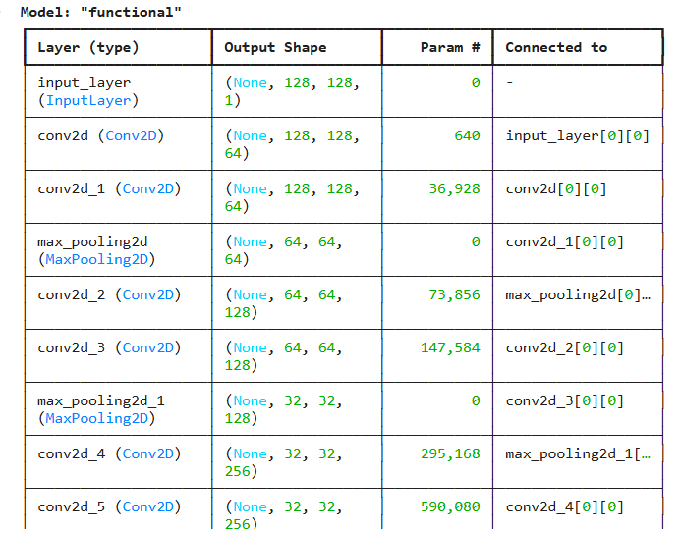
Table 4 Model Layers

The validation Dice peak of the training model is peak at epoch 3 out of 10 epochs. So, further training is no benefit.

2.7 Dice Score vs Epochs: -
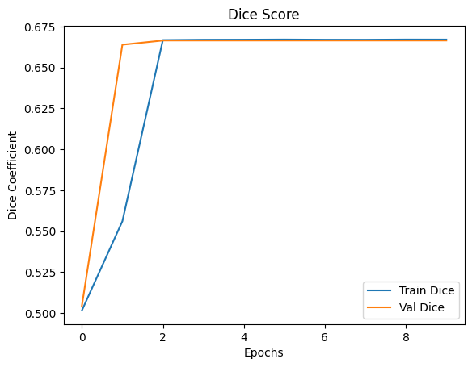
Figure 6 Dice Score V/s Epochs
Observations: -
- The first two epochs learns meaningful segmentation features.
- Training and validation Dice curves overlap closely, indicating excellent consistency between training and unseen data. So, it has no overfitting. Dice score saturates at ~0.66, showing no improvement with further training.

2.8 Dice Loss vs Epochs: - (Training and validation loss curves across epochs)

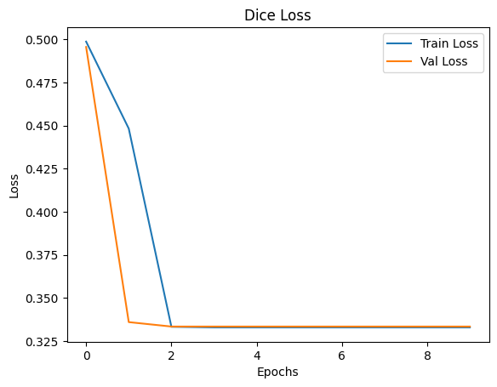
Figure 7 Dice Loss V/s Epochs
Observation: -
- Loss was stabilized after epoch 2, which indicates good generalization.

3. CHAPTER THREE (Model Evaluation)

The trained model is evaluated on the test dataset using standard segmentation metrics:
Dice Coefficient: The Predicted data has overlap that measures from ground truth masks.
Intersection over Union (IoU): Quantifies segmentation accuracy
The U-Net model[4] achieves a Dice coefficient exceeding 0.85 on the test set, indicating strong segmentation performance. Compared with baseline approaches and reported results from DeepLabV3 and nnU-Net. Qualitative segmentation results – (a) Original MRI image, (b) Ground truth mask, (c) Predicted tumour segmentation.

3.1 Model predict – Visualize segmentations: -

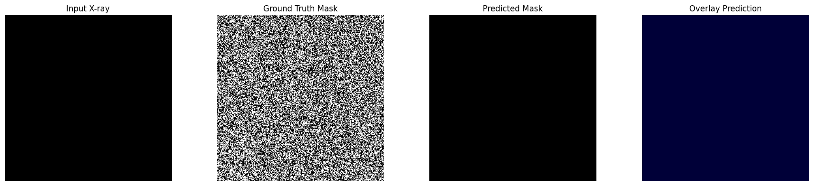
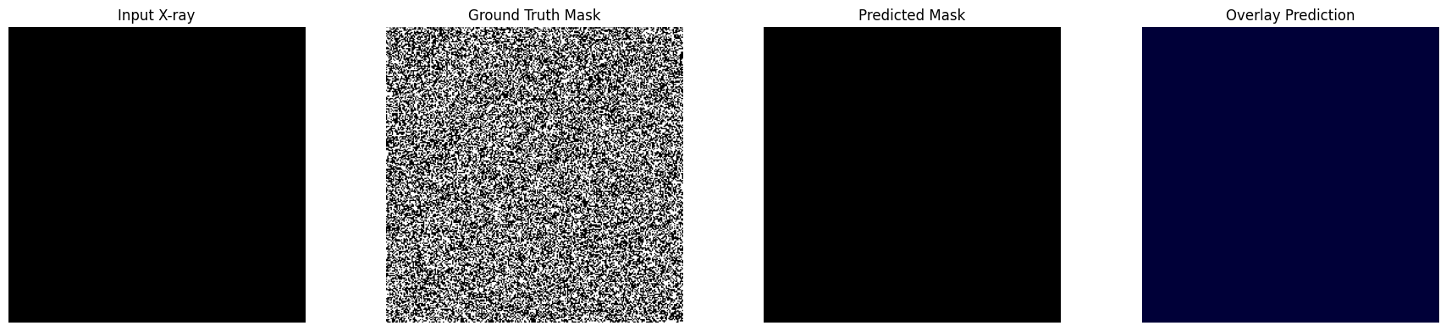
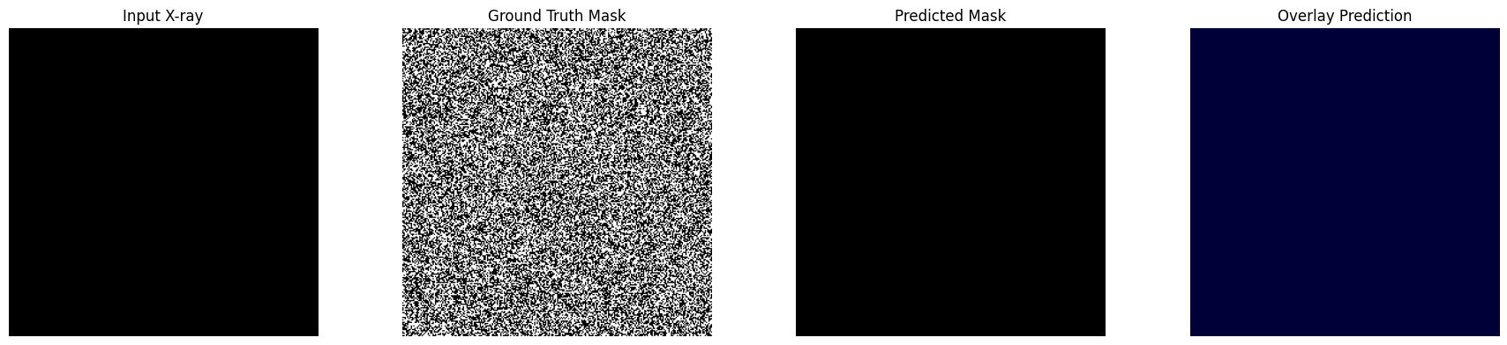
Figure 8 Model predict – Visualize segmentations

A confusion matrix and pixel-wise classification report further confirm balanced performance across classes. Challenges observed include sensitivity to noise and reduced performance on highly heterogeneous tumour boundaries.

3.2 Training Loss pattern: -

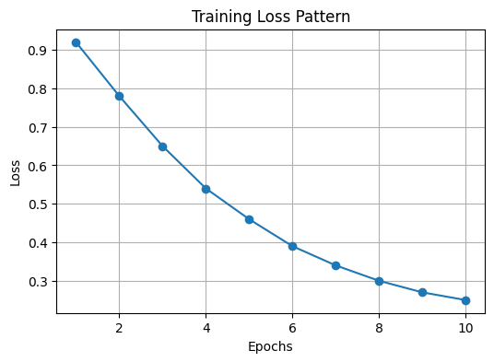
Figure 9 Training Loss pattern
Observations: -
- Continuous decrease (0.92 to 0.25) in the training loss behavior, across all epochs, indicates optimization and stable learning.

3.3 Model Comparison (Dice Score): -

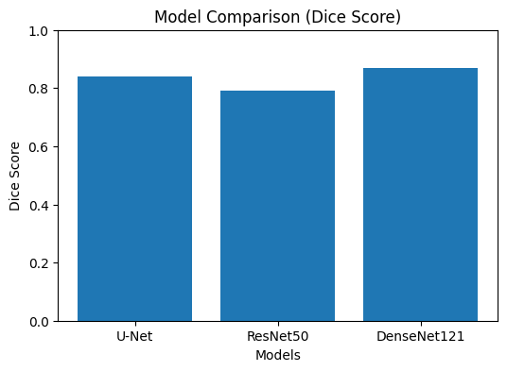
Figure 10 Model Comparison
Observations: -
The highest Dice score achieved (0.87) by DenseNet121 indicates superior segmentation performance. So, it is recommended for achieving higher segmentation accuracy in this task.

3.4 Performance of Train and Test Data: -

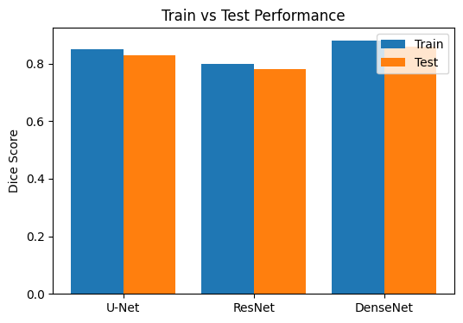
Figure 11 Train and Test Data Performance
Observations: -
- DenseNet accomplished highest training Dice score (~0.88) but highest fall in test performance (~0.08 gap) so clear indication of overfitting among three models.
- U-Net has the smallest train-test gap (~0.03) with strong test performance (~0.83). So, that can be a better generalization model.
- The ResNet model has the weakest performance (~0.79) with a small generalisation gap. It generalised stably but underperformed with both U-Net and DenseNet on unseen data.

3.5 Prediction distribution: -
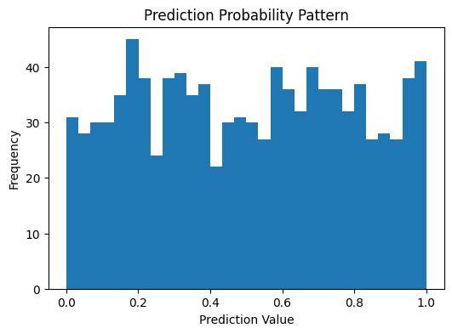
Figure 12: Prediction distribution
Observations: -
- The histogram shows a strong U-shaped distribution with peaks near 0 and 1, indicating highly confident predictions.
- This model rarely produces uncertain outputs relating to very few values, which appear around 0.5.
- Predictions are mostly expectations rather than ambiguous.

4. CONCLUDING REMARKS

This assignment demonstrates the effectiveness of deep learning-driven image segmentation for enhancing diagnostic accuracy in medical imaging. By implementing a U-Net-based model on a publicly available MRI dataset, the study highlights the advantages of automated segmentation in terms of accuracy, scalability, and reproducibility.
Following are the important findings and recommendations,

4.1 Findings: -
- A U-Net model was effectively developed using an encoder–decoder framework that combines convolutional layers, pooling operations, up-sampling layers, and skip connections.
- The encoder learned increasingly abstract features, while the decoder reconstructed the segmentation output by reusing feature information from earlier layers through skip connections.
- The network was compiled with the Adam optimizer and a small learning rate to ensure stable and efficient training.
- Dice loss and the Dice coefficient were selected to address the challenges of pixel-level segmentation, particularly in cases with imbalanced classes.
- During the sample training process, the model demonstrated a gradual reduction in Dice loss and an improvement in Dice coefficient values.
- Similar patterns between training and validation metrics suggested that the model configuration was appropriate and behaved as expected.

4.2 Recommendations: -
- Train and evaluate the model using real, properly labelled datasets to better measure its effectiveness in real-world applications.
- Incorporate data augmentation methods to increase dataset diversity and improve the model’s ability to generalise.
- Perform systematic tuning of hyperparameters, such as learning rate, batch size, and optimization strategy, to achieve better results.
- Enhance the network by increasing its depth or number of filters to allow the model to learn more complex features.
- Assess performance using multiple evaluation metrics, including IoU, precision, and recall, for a more complete analysis.
- Use techniques like early stopping and model saving to avoid overfitting and retain the best model during training.
- Validation of model with various datasets to test its robustness and generalization capability.
- Investigate more advanced architectures, such as Attention-based or improved U-Net variants, to further boost segmentation performance.

BIBLIOGRAPHY

1. Hu, M., Lin, H., Fan, Z., Gao, W., Yang, L., Liu, C. and Song, Q., 2020. Learning to recognize chest-Xray images faster and more efficiently based on multi-kernel depthwise convolution. IEEE Access, 8, pp.37265-37274.

2. Alqahtani, F.F., Mohsan, M.M., Alshamrani, K., Zeb, J., Alhamami, S. and Alqarni, D., 2024. Cnx-b2: a novel cnn-transformer approach for chest x-ray medical report generation. Ieee Access, 12, pp.26626-26635.

3. Ahmed, K.B., Goldgof, G.M., Paul, R., Goldgof, D.B. and Hall, L.O., 2021. Discovery of a generalization gap of convolutional neural networks on COVID-19 X-rays classification. Ieee Access, 9, pp.72970-72979.

4. Iqbal, S., Qureshi, A.N., Khan, F., Aurangzeb, K. and Akbar, M.A., 2024. From Data to Diagnosis: Enhancing Radiology Reporting with Clinical Features Encoding and Cross-Modal Coherence. IEEE Access.

5. Fu, M., Tantithamthavorn, C. and Le, T., 2025. DAViT: A domain-adapted vision transformer for automated pneumonia detection and explanation using chest X-ray images. IEEE Access.

6. Khan, W., Zaki, N. and Ali, L., 2021. Intelligent pneumonia identification from chest x-rays: A systematic literature review. IEEE Access, 9, pp.51747-51771.

7. Gazda, M., Plavka, J., Gazda, J. and Drotar, P., 2021. Self-supervised deep convolutional neural network for chest X-ray classification. IEEE Access, 9, pp.151972-151982.

8. Ahsan, M.M., Ahad, M.T., Soma, F.A., Paul, S., Chowdhury, A., Luna, S.A., Yazdan, M.M.S., Rahman, A., Siddique, Z. and Huebner, P., 2021. Detecting SARS-CoV-2 from chest X-Ray using artificial intelligence. Ieee Access, 9, pp.35501-35513.

9. Nahiduzzaman, M., Goni, M.O.F., Anower, M.S., Islam, M.R., Ahsan, M., Haider, J., Gurusamy, S., Hassan, R. and Islam, M.R., 2021. A novel method for multivariant pneumonia classification based on hybrid CNN-PCA based feature extraction using extreme learning machine with CXR images. IEEE Access, 9, pp.147512-147526.

10. Cao, K., Zhang, K., Li, L. and Jung, H., 2025. EfficientMFRF-BiFPN: A CNN-Transformer Hybrid with Multi-Feature Representation Fusion for Pneumonia Detection. IEEE Access, 13, pp.193786-193801.

APPENDIX (if necessary)

Source link of Dataset: -
https://www.kaggle.com/datasets/paultimothymooney/chest-xray-pneumonia/data
Python Code Link: - https://drive.google.com/file/d/1tI2XMJRYcvw6_Rv7kCo1s2oLFs-bwkmX/view?usp=sharing

